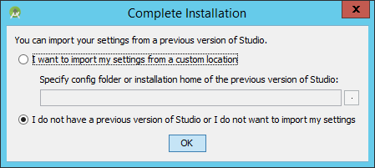
Click Next
Select Custom
Choose theme
Choose ellipses to browse
Type in C:\ProgramData\Andriod
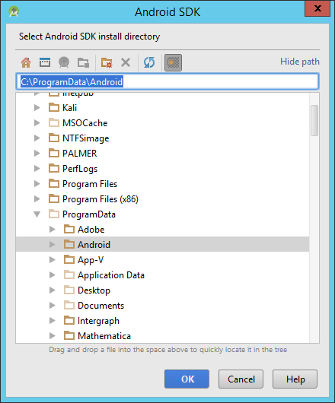
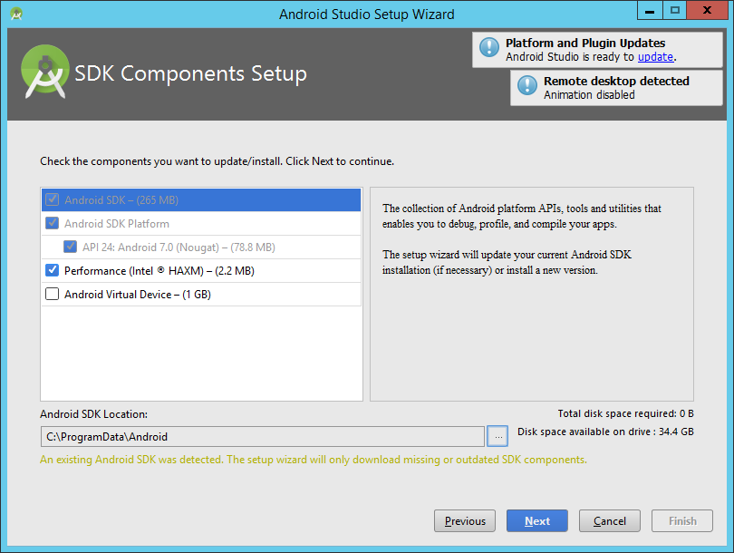
Next
Next
Finish

